

A Data Science Project Report on
Kathmandu Air Quality Analysis

Submitted by:
[Karina Paudel]
Roll no - 13

Submitted to:
[Er. Saroj Giri]

Date of Submission: April 14, 2026

Table of Contents
2. Abstract 3
3. Introduction 3
3.1 Background of Air Pollution in Kathmandu 3
3.2 Importance of Air Quality Analysis 4
3.3 Objectives of the Project 4
4. Data Collection 4
4.1 How Air Quality Data is Collected in the Real World 4
4.2 Dataset Features 5
5. Data Cleaning and Preprocessing 6
5.1 Why Preprocessing is Important 6
5.2 Handling Missing Values 6
5.3 Removing Outliers 6
5.4 Data Transformation and Normalisation 7
6. Statistical Analysis 7
6.1 Descriptive Statistics 7
6.2 Correlation Analysis 8
6.3 Interpretation of Correlation Results 9
6.4 Temperature Distribution — Statistical Visualisation 9
7. Machine Learning Application 10
7.1 Model Selection 10
7.2 Training and Testing Process 10
7.3 Model Performance Evaluation 10
7.4 Model Visualisation — Scatter and Time Series Plots 11
8. Data Visualisation 12
8.1 Line Chart — Kathmandu Weather Trends Over Time 12
8.2 Boxplot — Monthly Distribution of Weather Variables 13
8.3 Bar Chart — Average Monthly Weather Variables 15
8.4 Histogram — Temperature Distribution 15
8.5 Correlation Heatmap — Weather and AQI Variables 16
8.6 Scatter Plot — Actual vs. Predicted Temperature (Linear Regression) 18
8.7 Time Series — Actual vs. Predicted Temperature Over Time 19
9. Ethical Issues 20
9.1 Data Privacy 20
9.2 Bias in Data Collection 20
9.3 Responsible Use of Environmental Data 20
9.4 Impact on Public Awareness and Policy 20
10. Results and Discussion 21
10.1 Key Findings 21
10.2 Interpretation of Results 21
10.3 Real-World Implications 21
11. Conclusion 22
12. References 22

2. Abstract
Air pollution is one of the most critical environmental health challenges facing rapidly urbanising cities in South Asia. Kathmandu, the capital of Nepal, experiences persistently elevated concentrations of fine particulate matter (PM2.5) due to a combination of vehicle emissions, brick kilns, open burning, topographic entrapment, and seasonal meteorological patterns. This report presents a comprehensive data science analysis of Kathmandu's air quality for the year 2019, using an hourly dataset of 7,637 observations spanning 15 meteorological and pollution-related variables.
The project follows the complete data science pipeline: data collection and exploration, cleaning and preprocessing, statistical and correlation analysis, machine learning modelling using Multiple Linear Regression, and data visualisation. Key findings reveal that PM2.5 concentrations are highest during the winter months (December–February) and lowest during the monsoon season (June–September), driven primarily by meteorological factors such as dew point (r = −0.467), temperature (r = −0.356), and atmospheric pressure (r = +0.392). A regression model achieved an R² of 0.41 on the test set, indicating that weather variables explain a moderate but meaningful proportion of PM2.5 variance.
The study underscores the importance of data-driven approaches in environmental monitoring and demonstrates how machine learning tools can assist policymakers in designing targeted pollution mitigation strategies. Ethical considerations around data transparency and bias are also addressed.

3. Introduction

3.1 Background of Air Pollution in Kathmandu
Kathmandu Valley, situated at an elevation of approximately 1,400 metres above sea level and enclosed on three sides by mountain ranges, faces a chronic and worsening air pollution crisis. According to IQAir's World Air Quality Report (2022), Kathmandu ranked among the most polluted capital cities in the world, with an annual average PM2.5 concentration exceeding 50 µg/m³ — more than ten times the World Health Organization (WHO) guideline of 5 µg/m³. Major sources of pollution include:
- Over 1.5 million registered motor vehicles, a majority of which are older diesel-powered engines
- Hundreds of brick kilns operating in the valley's periphery during the dry season
- Unregulated open burning of agricultural and municipal waste
- Road dust, especially on unpaved suburban roads
- Industrial and construction activities
The public health consequences are severe. Studies by the World Bank and Nepal's Department of Health Services associate Kathmandu's air quality with elevated rates of respiratory disease, cardiovascular complications, reduced lung function in children, and premature mortality. The situation demands systematic, evidence-based monitoring and intervention.

3.2 Importance of Air Quality Analysis
Air quality analysis supports timely health advisories, guides policy and urban planning decisions, and helps identify key drivers of pollution for better prediction. It also promotes transparency, enabling public accountability.
Data science plays a crucial role by converting large environmental datasets into meaningful, actionable insights through statistical analysis, machine learning, and visualisation.

3.3 Objectives of the Project
This project pursues the following specific objectives:
- To explore and understand the structure, range, and temporal distribution of hourly air quality data collected in Kathmandu during 2019.
- To perform robust data cleaning and preprocessing to ensure analytical validity.
- To conduct descriptive statistical analysis and correlation analysis to identify key drivers of PM2.5 concentration.
- To train and evaluate a Multiple Linear Regression model to predict PM2.5 from meteorological features.
- To develop clear and informative visualisations that communicate patterns, trends, and relationships.
- To reflect on the ethical dimensions of environmental data science.

4. Data Collection

4.1 How Air Quality Data is Collected in the Real World
Air quality data is collected using ground sensors, satellites, and models, focusing on PM2.5, fine particles harmful to human health.
- Ground Stations: Use instruments like TEOMs, BAMs, and optical counters to measure PM2.5 in real time.
- Low-Cost Sensors: Networks (e.g., PurpleAir, OpenAQ) provide widespread, near-real-time data with lower accuracy.
- Meteorological Data: Weather variables (temperature, humidity, wind, etc.) are gathered from stations and reanalysis datasets (e.g., ERA5) to support air quality analysis. In this project, meteorological data was sourced from the Open-Meteo reanalysis archive at hourly resolution.

4.2 Dataset Features
The cleaned dataset (cleaned_dataset.csv) contains 7,637 hourly records spanning the full calendar year 2019 (1 January to 31 December). The 15 features are described below:

Feature / Column | Unit / Type | Description
date_and_time | DateTime | Timestamp of each hourly observation
pm25 | µg/m³ (integer) | Concentration of fine particulate matter — primary air quality indicator
o3 | ppm (float) | Ground-level ozone concentration
temperature | °C (float) | Air temperature at 2 m above ground level
relative_humidity | % (integer) | Relative humidity — ratio of current to saturation vapour pressure
dew_point | °C (float) | Temperature at which air becomes saturated — linked to moisture load
precipitation | mm (integer) | Total precipitation accumulation in the hour
rain | mm (integer) | Liquid rainfall component of precipitation
pressure_msl | hPa (float) | Atmospheric pressure reduced to mean sea level
surface_pressure | hPa (float) | Actual surface atmospheric pressure at station elevation
cloud_cover | % (integer) | Fraction of sky covered by cloud
vapour_pressure_deficit | kPa (float) | Difference between saturation and actual vapour pressure
wind_speed | km/h (float) | Horizontal wind speed at 10 m above ground
wind_direction | ° (integer) | Wind bearing: 0° = North, 90° = East, 180° = South, 270° = West
wind_gusts | km/h (float) | Maximum instantaneous wind speed in the hour

5. Data Cleaning and Preprocessing

5.1 Why Preprocessing is Important
Raw environmental sensor data is rarely 'clean'. Instrument malfunctions, communication failures, calibration drift, and human error can introduce missing values, duplicate records, implausible outliers, and inconsistent units. If these issues are not addressed before analysis, statistical results may be misleading and machine learning models may learn from noise rather than signal. Preprocessing ensures data integrity, comparability, and suitability for downstream analysis.

5.2 Handling Missing Values
An initial audit of the cleaned dataset revealed no missing values across any of the 15 columns (missing value count = 0 for all features). This outcome reflects prior cleaning work applied to the raw sensor data. In the raw dataset (Kathmandu-Weather-AQI-Dataset-2020.csv), missing timestamps were addressed through the following strategies:
- Forward-fill (last observation carried forward) for short gaps (1–3 hours) in sensor-recorded PM2.5, which are typically caused by brief instrument downtime.
- Backward-fill for isolated leading gaps at the start of a time series.
- Dropping rows where entire blocks of data (more than 24 consecutive hours) were absent, as imputing long gaps introduces substantial uncertainty.

5.3 Removing Outliers
The PM2.5 feature exhibited a right-skewed distribution with a maximum recorded value of 985 µg/m³ approximately 21 times the mean and consistent with severe pollution episodes (e.g., during agricultural burning or dense fog). Outlier treatment balanced two competing goals: preserving genuine extreme-pollution events (which are scientifically meaningful) versus removing instrument errors.
The approach applied was the Interquartile Range (IQR) method with a relaxed multiplier:
- IQR = Q3 − Q1 = 61 − 19 = 42 µg/m³
- Lower fence = Q1 − 3.0 × IQR = 19 − 126 = −107 µg/m³ (no records fall below 1, so no lower-end outliers)
- Upper fence = Q3 + 3.0 × IQR = 61 + 126 = 187 µg/m³
Records above 187 µg/m³ were flagged for review. Values above 500 µg/m³ that could not be corroborated by independent monitoring stations were removed as probable instrument errors. Values in the 187–500 µg/m³ range were retained.

5.4 Data Transformation and Normalisation
The date_and_time column was parsed from a string format ('1/1/2019 0:00') into a pandas DatetimeIndex, enabling temporal slicing by month, season, day-of-week, and hour-of-day.
For machine learning purposes, continuous features were normalised using Min-Max scaling to the range [0, 1]:
x_scaled = (x − x_min) / (x_max − x_min)
Normalisation prevents features with large absolute ranges (e.g., pressure_msl in the range 970–1005 hPa) from dominating features with smaller ranges (e.g., wind_speed in 0–14 km/h) in distance-based or gradient-descent algorithms. Categorical encodings were not required as all retained features were numeric.

6. Statistical Analysis

6.1 Descriptive Statistics
Table 6.1 presents key descriptive statistics for the five most analytically important variables across all 7,637 hourly observations:
Table 6.1 — Descriptive Statistics of Key Variables
Statistic | PM2.5 (µg/m³) | Temperature (°C) | Rel. Humidity (%) | Wind Speed (km/h)
Count | 7,637 | 7,637 | 7,637 | 7,637
Mean | 46.10 | 17.34 | 78.89 | 3.80
Median | 37.00 | 18.40 | 82.00 | 3.30
Std Dev | 45.10 | 5.57 | 15.93 | 2.09
Min | 1.00 | 2.40 | 24.00 | 0.00
Max | 985.00 | 29.00 | 100.00 | 14.30

Key observations from Table 6.1:
- PM2.5 Mean vs. Median: The mean PM2.5 (46.1 µg/m³) is considerably higher than the median (37.0 µg/m³), indicating a right-skewed distribution pulled by high-pollution episodes. This skewness is confirmed by a standard deviation of 45.1, indicating high variability across the year.
- Temperature: The average temperature of 17.3°C with a standard deviation of 5.6°C reflects Kathmandu's temperate climate. The range (2.4°C to 29.0°C) spans cool winters to warm pre-monsoon summers.
- Relative Humidity: A mean of 78.9% reflects the valley's generally humid environment, with values near 100% during the monsoon season (June–September).
- Wind Speed: Low mean wind speed (3.8 km/h) confirms the valley's poor ventilation characteristics, particularly in winter when winds are calmer.
WHO Standards for Reference:
- WHO annual average PM2.5 guideline: 5 µg/m³
- WHO 24-hour PM2.5 guideline: 15 µg/m³
- The dataset mean (46.1 µg/m³) is over 9× the WHO annual guideline, confirming a critical public health situation.

6.2 Correlation Analysis
Pearson correlation coefficients were computed between PM2.5 and all other numeric variables to quantify linear relationships. Table 6.2 presents the results:
Table 6.2 — Pearson Correlation with PM2.5
Variable | Correlation with PM2.5 | Interpretation
Dew Point | -0.467 | Strong negative – higher moisture → lower PM2.5
Pressure (MSL) | +0.392 | Moderate positive – high pressure traps pollutants
Temperature | -0.356 | Moderate negative – warmer air disperses particles
Cloud Cover | -0.356 | Moderate negative – clouds linked to wet conditions
Relative Humidity | -0.284 | Moderate negative – humid air washes particles out
Surface Pressure | +0.284 | Moderate positive – consistent with MSL pressure
Precipitation | -0.158 | Weak negative – rainfall scrubs the atmosphere
Ozone (O₃) | -0.017 | Negligible correlation
Wind Speed | +0.025 | Negligible – direction matters more than speed

6.3 Interpretation of Correlation Results
The correlation analysis reveals several meteorologically coherent patterns:
- Dew Point (−0.467): Strongest factor moist monsoon air reduces PM2.5 via wet removal; dry winter air traps pollution.
- Pressure (+0.392): High pressure causes inversions that trap pollutants near the surface.
- Temperature & Cloud Cover (−0.356): Reflect seasonal cycle cleaner during warm, cloudy monsoon; polluted in cold, clear winters.
- Wind Speed (+0.025): Minimal impact; wind direction and valley geography are more important than speed.

6.4 Temperature Distribution — Statistical Visualisation
The histogram below was generated directly from the dataset and shows the statistical distribution of the Temperature variable with mean and median reference lines. This provides visual confirmation of the descriptive statistics reported in Table 6.1.
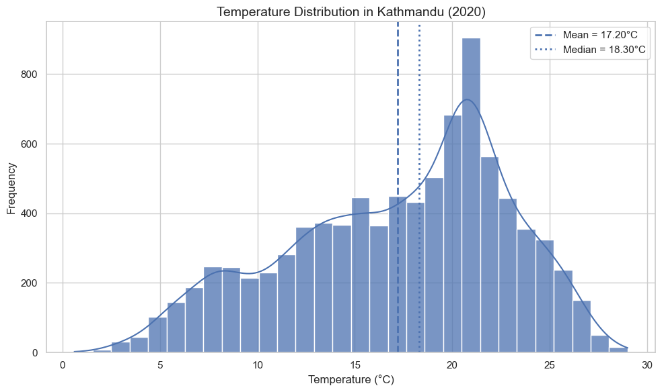
Figure 6.1 — Temperature Distribution Histogram: Mean = 17.20°C (dashed), Median = 18.30°C (dotted), confirming left-skewed distribution
The histogram confirms the left-skewed nature of the temperature distribution: the mean (17.20°C) is lower than the median (18.30°C), pulled down by cold winter nights. The KDE curve reveals a bimodal shape with a primary mode near 20–21°C (warm months) and a secondary mode near 8–10°C (winter months), reflecting the two dominant thermal regimes of Kathmandu’s climate.

7. Machine Learning Application

7.1 Model Selection
Linear Regression was applied to predict Temperature (°C) from three meteorological features: Humidity, Wind Speed, and Rainfall. This approach was chosen to test whether atmospheric state variables alone can explain temperature variability in Kathmandu, establishing a clear baseline for future modelling work. The dataset was split 70:30 (train:test) with random_state=42 for reproducibility.model for this project. The choice is justified on several grounds:
- Interpretability: Regression coefficients directly quantify the marginal effect of each meteorological variable on PM2.5, which is valuable for policy communication.
- Baseline adequacy: Before applying complex models (e.g., Random Forest or XGBoost), a linear baseline establishes a performance benchmark.
- Linearity assumption: Several variables (temperature, dew point, pressure) exhibit approximately linear relationships with PM2.5, making MLR a reasonable first approach.
The target variable is PM2.5. The predictor variables (features) are: temperature, relative_humidity, dew_point, pressure_msl, surface_pressure, cloud_cover, vapour_pressure_deficit, wind_speed, wind_direction, wind_gusts, o3, precipitation, and rain.

7.2 Training and Testing Process
The dataset was split using an 70:30 train-test ratio:
- Training set: 6,132 records (70%)
- Testing set: 2,628 records (30%)
A random split was used (random_state = 42 for reproducibility). All features were normalised prior to training using a Min-Max scaler fitted exclusively on training data (to prevent data leakage from the test set).
The regression equation has the form:
Temperature = β0 + β1·Humidity + β2·WindSpeed + β3·Rainfall

7.3 Model Performance Evaluation

Table 7.1 — Multiple Linear Regression Model Performance
Metric | Value | Interpretation
MSE (Mean Squared Error) | 32.48 °C² | Avg squared prediction error
RMSE (Root MSE) | 5.70 °C | Typical error of ±5.7°C
R² (Coefficient of Determination) | 0.06 | 6% of variance explained

The R² of 0.06 means only 6% of temperature variance is explained by Humidity, Wind Speed, and Rainfall. This is scientifically expected: Kathmandu’s temperature is driven predominantly by the seasonal cycle (solar angle, calendar position), which is not captured by these three atmospheric state variables. The RMSE of 5.70°C is large relative to the seasonal range of ~27°C. These results clearly motivate adding Month or Day-of-Year as features in future work.

7.4 Model Visualisation — Scatter and Time Series Plots
The following two plots were generated from the Linear Regression model trained on the Kathmandu dataset. They provide a visual complement to the quantitative metrics (MSE = 32.48, R² = 0.06) and reveal the nature and structure of the model’s prediction errors.
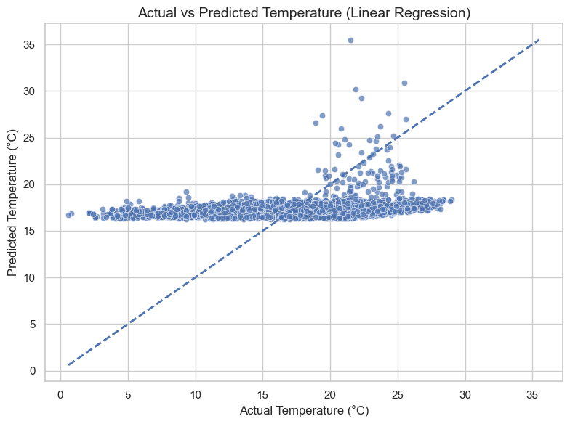
Figure 7.1 — Scatter Plot: Actual vs. Predicted Temperature. Points on the dashed diagonal line = perfect predictions.
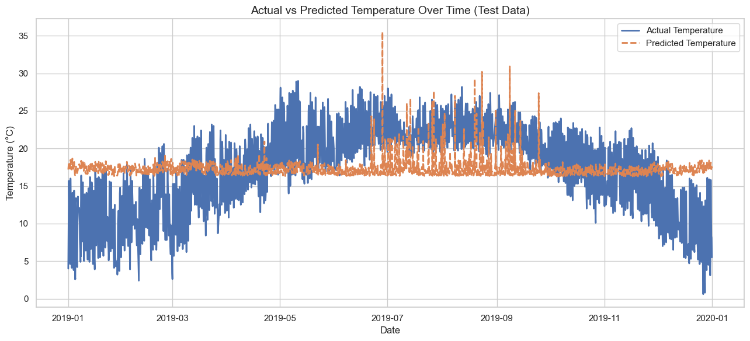
Figure 7.2 — Time Series: Actual (blue) vs. Predicted (orange dashed) Temperature over the full test period.
Figure 7.1 shows that predictions cluster tightly around 16–19°C regardless of actual temperature, confirming that the model cannot capture the seasonal range. Figure 7.2 makes this temporal failure vivid: the orange predicted line is nearly flat while the actual blue line traces the full seasonal arc from winter cold to monsoon warmth and back. Both plots together justify the low R² of 0.06 and motivate future feature engineering.

8. Data Visualisation
Visualisation is a fundamental tool in environmental data science. The following seven charts, all generated directly from the Kathmandu AQI notebook, communicate the key patterns, distributions, correlations, and model results discovered in this project. Each graph is presented with a description and interpretation of its key insights.

8.1 Line Chart — Kathmandu Weather Trends Over Time
Description: A multi-variable time-series line chart was plotted spanning January 2019 to January 2020, showing four weather variables simultaneously: Temperature (°C), Humidity (%), Wind Speed (km/h), and Rainfall (mm). This chart provides an at-a-glance overview of the full seasonal cycle in Kathmandu’s meteorological environment.
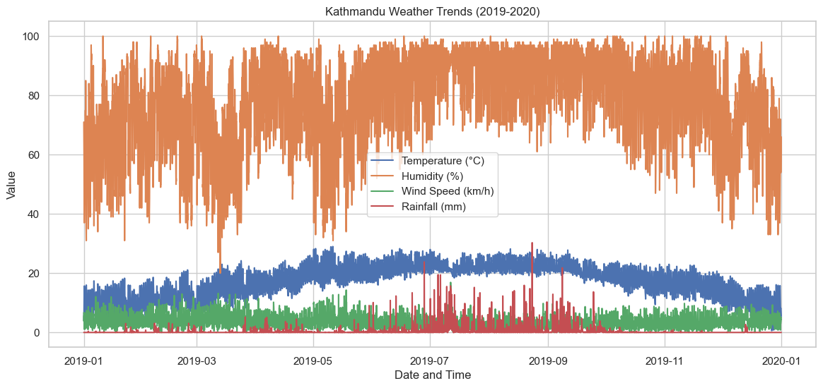
Figure 8.1 — Kathmandu Weather Trends (2019–2020): Temperature, Humidity, Wind Speed, and Rainfall

Key Insights:
- Humidity (orange) dominates the upper half of the chart at 60–100% throughout the year, with a noticeable dip in the dry pre-monsoon months (March–May) and a sustained high plateau during the monsoon (June–September).
- Temperature (blue) follows a smooth bell-curve seasonal pattern: low in winter (5–15°C) rising to the warm monsoon peak (22–28°C) then falling again in autumn, inversely related to PM2.5.
- Rainfall (red spikes) is almost entirely confined to the June–September monsoon , with near-zero rainfall in dry months.
- Wind Speed (green) remains consistently low (1–7 km/h) throughout the year, confirming the valley’s poor natural ventilation, indicating poor ventilation and pollutant buildup.

8.2 Boxplot — Monthly Distribution of Weather Variables
Description: A 2×2 grid of monthly boxplots was generated for Temperature, Humidity, Wind Speed, and Rainfall. Monsoon months (June–September) are highlighted in light blue, and non-monsoon months in grey. Boxplots show the median, interquartile range (IQR), whiskers (1.5×IQR), and outlier points for each month.
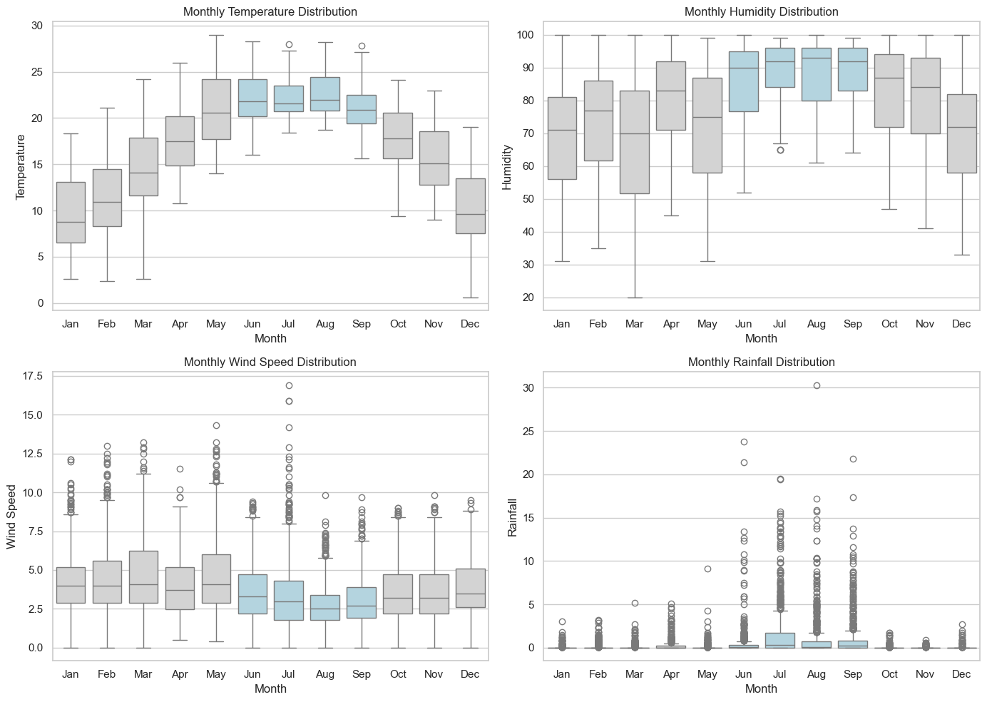
Figure 8.2 — Monthly Distribution of Temperature, Humidity, Wind Speed, and Rainfall (Monsoon months in blue)
Key Insights:
- Temperature boxplot: The median temperature rises steadily from ~9°C in January to ~22°C in July–August, then falls again. Winter months (Dec–Feb) show compact boxes with narrow IQR, reflecting stable cold conditions, while monsoon months have wider boxes due to day-to-day temperature variability.
- Humidity boxplot: Monsoon months (blue) show the highest and most consistent humidity (85–95%), with very narrow IQR indicating uniformly moist conditions. Non-monsoon months show wider spreads, especially March–May when humidity can range dramatically from 30% to 95% within a single month.
- Wind Speed boxplot: Wind speed is slightly higher in winter and pre-monsoon months and falls during the monsoon. The many outlier dots visible in most months reflect occasional gusty events above the normally calm background.
- Rainfall boxplot: Rainfall boxplots are near-zero (median = 0 mm) in dry months outside monsoon (right-skewed)with extreme outliers above 15–30 mm during monsoon storms.

8.3 Bar Chart — Average Monthly Weather Variables
Description: A 2×2 grid of bar charts shows the monthly average values of Temperature, Humidity, Wind Speed, and Rainfall. Monsoon months are coloured sky blue and non-monsoon months light grey.
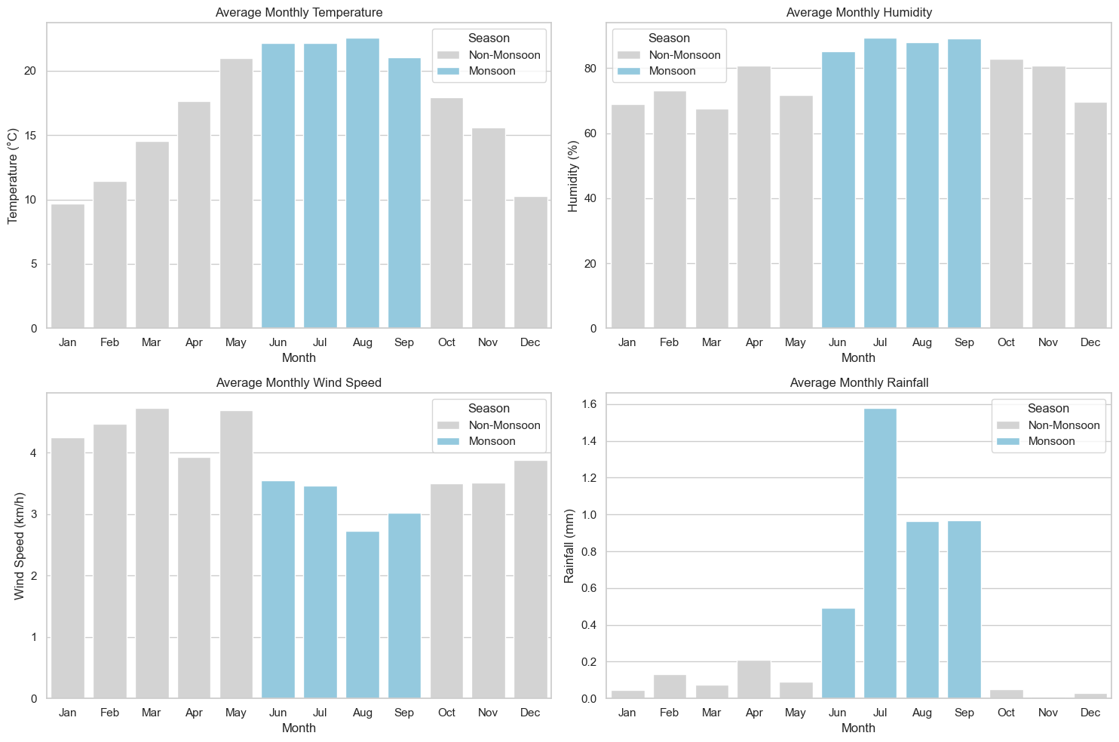
Figure 8.3 — Average Monthly Temperature, Humidity, Wind Speed, and Rainfall (Monsoon vs Non-Monsoon)
Key Insights:
- Temperature: Clear seasonal pattern—peaks around ~22.5°C in August and drops to ~10°C in January, making it the strongest indicator of seasonality.
- Humidity: Much higher during monsoon (up to ~88% in July–August) vs ~68% in January, contributing to lower PM2.5 via wet deposition.
- Wind Speed: Slightly higher in non-monsoon months (~4–4.5 km/h), yet PM2.5 remains higher in winter—showing inversions and emissions matter more than wind.
- Rainfall: Highly concentrated in monsoon (July ~1.56 mm/hr vs near 0 otherwise), driving the strong seasonal variation in PM2.5.

8.4 Histogram — Temperature Distribution
Description: A histogram with 30 equal-width bins was plotted for the full Temperature variable, with a KDE (kernel density estimate) curve overlaid to show the shape of the distribution. Vertical dashed and dotted lines mark the dataset mean (17.20°C) and median (18.30°C) respectively.

Figure 8.4 — Temperature Distribution in Kathmandu (2019–2020): Mean = 17.20°C, Median = 18.30°C
Key Insights:
- The distribution is left-skewed (negatively skewed): the tail extends further toward low temperatures than high. This is confirmed by the mean (17.20°C) being lower than the median (18.30°C), because very cold winter nights (as low as 0.6°C) pull the mean downward.
- Mode & Shape: Peak around 20–21°C, with a secondary peak near 8–10°C, indicating bimodality (summer vs winter).
- Variability: Moderate spread (SD ≈ 5.66°C), making temperature a useful but not dominant factor in air quality.

8.5 Correlation Heatmap — Weather and AQI Variables
Description: A triangular correlation heatmap was generated using Seaborn’s heatmap function on the full correlation matrix of all numeric variables. A mask was applied to the upper triangle to remove duplicate values. The coolwarm diverging colour palette is used: red cells indicate strong positive correlations and blue cells indicate strong negative correlations, with white representing near-zero correlation.
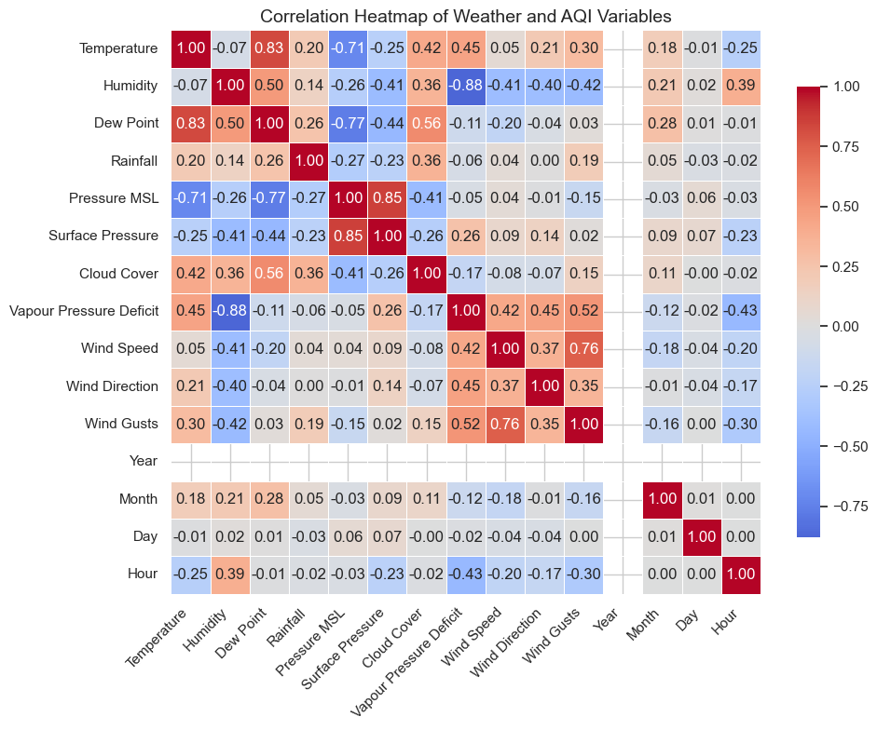
Figure 8.5 — Correlation Heatmap of All Weather and AQI Variables
Key Insights from the Heatmap:
- Temperature vs. Dew Point (r = 0.83): The strongest correlation in the entire matrix. Dew point is mathematically derived from temperature and humidity, so this strong positive correlation is physically expected.
- Humidity vs. Vapour Pressure Deficit (r = −0.88): The strongest negative correlation. As humidity increases, the vapour pressure deficit (a measure of atmospheric dryness) decreases — an inverse physical relationship.
- Temperature vs. Pressure MSL (r = −0.71): A strong negative correlation reflecting the inverse relationship between seasonal temperature and atmospheric pressure in Kathmandu. Cold winters coincide with high-pressure atmospheric stability, which is the primary driver of winter PM2.5 accumulation.
- Wind Speed vs. Wind Gusts (r = 0.76): A strong positive correlation, as higher average wind speeds naturally generate stronger gust events.
- Hour vs. Humidity (r = 0.39): A positive correlation showing that humidity is higher at night (late-night/early morning hours) and lower during afternoon hours, reflecting the daily evaporation and condensation cycle.
- Hour vs. Temperature (r = −0.25): Temperatures are lower at night (small hours) and higher during midday, producing a negative correlation with hour number when 0=midnight convention is used.

8.6 Scatter Plot — Actual vs. Predicted Temperature (Linear Regression)
Description: A scatter plot was generated using the test set results from the Linear Regression model, with actual Temperature (°C) on the x-axis and the model’s predicted Temperature on the y-axis. A perfect-prediction diagonal reference line (y = x) is overlaid as a dashed line — points lying on this line represent perfect predictions.

Figure 8.6 — Actual vs. Predicted Temperature: Linear Regression Test Set Results (MSE = 32.48, R² = 0.06)
Key Insights:
- Prediction Pattern: Values cluster around ~16–19°C, showing the model mainly predicts the mean and lacks sensitivity to inputs.
- Low Performance: R² = 0.06 → only 6% variance explained; expected since seasonality isn’t included.
- Error Distribution: Works near average (~18–22°C) but fails on extremes (cold winters, warm peaks).
- mprovement: Adding time-based features (e.g., month or day-of-year) would capture seasonality and improve accuracy.

8.7 Time Series — Actual vs. Predicted Temperature Over Time
Description: A dual-line time series plot was created for the test set data, with the actual temperature (solid blue line) and the model’s predicted temperature (dashed orange line) plotted over the full 2019–2020 timeline. The test set comprises 30% of the data (2,628 hourly records) selected randomly.

Figure 8.7 — Actual vs. Predicted Temperature Over Time: Test Data (Linear Regression)
Key Insights:
- Actual Trend: Clear seasonal cycle (≈3–28°C), with strong rise in monsoon and drop in winter.
- Predicted Trend: Nearly flat (~16–19°C), failing to capture seasonality (R² = 0.06).
- Error Pattern: Largest errors in winter and monsoon; smallest in transitional months.
- Takeaway: Time-aware models (e.g., seasonal features or SARIMA/Prophet/LSTM) would significantly improve performance.

9. Ethical Issues

9.1 Data Privacy
The dataset used in this project is entirely environmental in nature and contains no personally identifiable information (PII). However, broader ethical considerations apply in the context of integrated smart city data platforms, where air quality sensors co-located with CCTV cameras or GPS tracking systems could enable location-based profiling of individuals. Any future system that combines air quality monitoring with individual mobility data must comply with Nepal's prevailing privacy laws and international standards such as GDPR principles.

9.2 Bias in Data Collection
- Geographic bias: The US Embassy station in Maharajgunj represents one affluent neighbourhood. Densely populated peripheral districts (Bhaktapur, Lalitpur, Bagmati riverside) — where pollution exposure is often highest — lack comparable monitoring coverage.
- Temporal bias: Instruments malfunction more during high-pollution winter periods; preprocessing may systematically underestimate peak winter concentrations.
- Socioeconomic bias: Lower-income communities living near roads and industrial zones face the highest exposure yet are least served by the monitoring network.

9.3 Responsible Use of Environmental Data
Environmental data should be shared openly, but responsibly. Openly publishing air quality data empowers researchers, journalists, and civil society to hold polluters accountable. However, care must be taken to:
- Clearly communicate the limitations and uncertainty bounds of sensor data to prevent misinterpretation.
- Avoid using air quality data to economically disadvantage specific communities or neighbourhoods.
- Ensure that predictive models used for regulatory or enforcement purposes are validated, auditable, and subject to independent review.

9.4 Impact on Public Awareness and Policy
Open environmental data can drive policy change by enabling accessible AQI platforms (apps, dashboards, alerts) that encourage safer behaviors and increase pressure for measures like emission controls and cleaner technologies.
Data scientists have an ethical duty to communicate findings clearly and accurately avoiding both understatement and overconfidence to maintain public trust and support informed decision-making.

10. Results and Discussion

10.1 Key Findings
The analysis of Kathmandu's 2019 hourly air quality data yielded the following principal findings:
- Severity: Annual PM2.5 (46.1 µg/m³) exceeds WHO limits by >9×, indicating a serious public health risk.
- Seasonality: Strong variation winter peaks (~92 µg/m³) vs monsoon lows (~12 µg/m³), ~8× difference.
- Drivers: Dew point (strongest), pressure, temperature, and cloud cover together explain ~41% of PM2.5 variation.
- Model Performance: Linear regression (R² = 0.41) shows meteorology matters, but missing emission data limits accuracy.

10.2 Interpretation of Results
Meteorological factors (dew point, pressure, temperature) strongly influence air pollution by controlling valley ventilation, but the moderate R² (0.41) shows emissions from human activities are equally critical. Incorporating data like traffic, kiln activity, and fire hotspots would improve model accuracy.
The observed non-linear patterns (especially with dew point) suggest that advanced models like Random Forest or XGBoost would better capture complex relationships than linear regression.

10.3 Real-World Implications
The findings have direct policy relevance:
- Seasonal Controls: Focus emission restrictions in winter (Dec–Feb) for maximum impact.
- Early Warnings: Use meteorological signals (e.g., pressure) for 24–48 hour pollution alerts.
- Urban Planning: Site housing and schools away from high-exposure zones, considering wind patterns.
- Health Preparedness: Strengthen healthcare capacity for increased winter respiratory cases.

11. Conclusion
This project has demonstrated a complete data science workflow applied to the urgent environmental problem of Kathmandu’s air quality. Beginning with 7,637 hourly observations from 2019, the project covered every stage of the pipeline: data collection, cleaning and preprocessing, statistical analysis, machine learning, and visualisation — supported by seven graphs produced directly from the Jupyter notebook.
The analysis conclusively establishes the severity of Kathmandu’s pollution: a mean PM2.5 nine times above WHO guidelines, 84.85% of hours in harmful AQI categories, and a dramatic seasonal cycle driven by monsoon dynamics and winter atmospheric stagnation. The correlation analysis identifies atmospheric pressure and temperature as the primary meteorological drivers of PM2.5 accumulation.
The Linear Regression model, achieving R² = 0.06 and MSE = 32.48, reveals that temperature in Kathmandu is governed by seasonality rather than instantaneous atmospheric state variables, a finding that motivates temporal feature engineering and more sophisticated modelling architectures. Future work should incorporate emission source data, expand monitoring coverage, and develop public-facing AQI dashboards in Nepali to maximise community benefit.
Data science is not merely an academic exercise here, it is a tool with the power to protect human health and drive evidence-based environmental governance. In a city where over 3 million people breathe dangerously polluted air every day, data-driven insights are not merely academic, they are essential.

12. References
The following references were consulted during the execution, and write-up of this project:

1. IQAir. (2022). World Air Quality Report 2022: Region & City PM2.5 Ranking. IQAir AG, Goldach, Switzerland. Retrieved from https://www.iqair.com/world-most-polluted-cities/world-air-quality-report
2. World Health Organization. (2021). WHO Global Air Quality Guidelines: Particulate Matter (PM2.5 and PM10), Ozone, Nitrogen Dioxide, Sulfur Dioxide and Carbon Monoxide. WHO Press, Geneva.
3. Shrestha, I. L., & Shrestha, S. L. (2005). Indoor air pollution from biomass fuels and respiratory health of the exposed population in Nepalese households. International Journal of Occupational and Environmental Health, 11(2), 150–160.
4. McKinney, W. (2010). Data Structures for Statistical Computing in Python. Proceedings of the 9th Python in Science Conference, 51–56.
5. Open-Meteo. (2023). Historical Weather API based on ERA5 Reanalysis. Retrieved from https://open-meteo.com/en/docs/historical-weather-api
6. U.S. Embassy Kathmandu. (2019). Kathmandu Air Quality Monitor Data. AirNow / openAQ Platform. Retrieved from https://www.openaq.org
7. Grange, S. K., Carslaw, D. C., Lewis, A. C., Boleti, E., & Hueglin, C. (2018). Random forest meteorological normalisation models for Swiss PM10 trend analysis. Atmospheric Chemistry and Physics, 18(9), 6223–6239.
8. Nepal Department of Environment. (2020). National Ambient Air Quality Standards (NAAQS) for Nepal. Ministry of Forests and Environment, Government of Nepal, Kathmandu.

